**Java Notes *Java notes by Ajit Sir...***

***Jspiders/Qspiders Btm***

***Contact : 9980500900***

--------------------------------------------------------------------------------------------------------------

What is a platform ?

→ Any software or hardware environment where a program runs is called a platform.

What is a software ?

→ It is a set of instructions or a program.

→ It is an automated solution to a real world challenges or problems.

What is a program ?

→ Program is a set of instructions or code.

What is programming language ?

→ It is a language using which a software can be developed.

What is Java ?

→ Java is a high level object oriented programming language.

What are the applications that can be developed using java ? No

→ Desktop applications( Media player, antivirus etc)

→ Web Applications (eg : Facebook, irctc.com)

→ Enterprise Applications (eg : banking application)

→ Mobiles

→ Games etc

Who developed Java ? No

→ Java was developed by James Gosling in 1996. (JDK version - 1.0) (JDK - Java Development Kit)

→ The latest version of JDK is 11.

→ It was developed by Sun Microsystem and now it is overtaken by Oracle corporation.

Why the language name is Java ? No

→ Java is the name of an island in Indonesia, where coffee was first produced. They have given the Java name in the name of that island.

What are the features of Java ?

→ Simple :-- it is very simple to learn and implement

→ Robust - Strong

→ High Performance

→ Portable

→ Object Oriented :

→ Everything in java is an object.

→ Few concepts of OOPs (Object Oriented Programming ) are below.

→ Class

→ Object

→ Inheritance

→ Polymorphism

→ Abstraction

→ Encapsulation

→ Multi Threaded

→ Platform Independent : Why java is platform independent ?

→ Java is a platform independent, because once we write java program, we can execute it in any platform. (WORA -- Write Once, Run Anywhere). Java code will be compiled into bytecode (.class file ) by the compiler and these byte code is platform independent. Means : it can be executed in any specific platform provided we have a platform specific Java runtime environment.

Note : JRE of windows system will be different from JRE of MAC system.

Difference between C++ and Java ? No

→ Java is platform independent whereas C++ is not.

→ Java does not support Multiple Inheritance with classes but C++ supports.

What is JDK, JRE and JVM ?

→ JDK contains both compiler (javac) and Java RunTime environment **(JRE)**.

→ JDK is a java development kit which is used to develop an application.

→ JRE further contains Java Virtual Machine (JVM) and a few other resource

→ JRE is the physical implementation of JVM and it provides a runtime

environment to execute the java programs.

→ JRE is platform dependent. Windows JRE is different from MAC JRE.

→ JVM stands for Java Virtual Machine. It is the specification of JRE.

→ JVM is responsible to convert the byte code in to system specific

instructions.

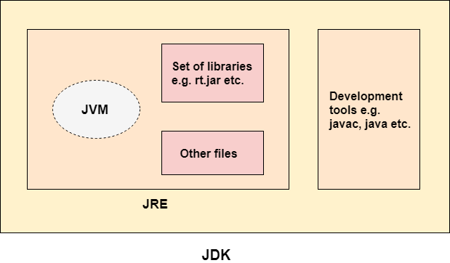

-------------------------------

Q : How do you install Java in your system ?

**JDK Installation Steps : no**

1. Go to this url..

<https://www.oracle.com/technetwork/java/javase/downloads/jdk8-downloads-2133151.html>

2. Select radio button -- Accept Licence Agreement

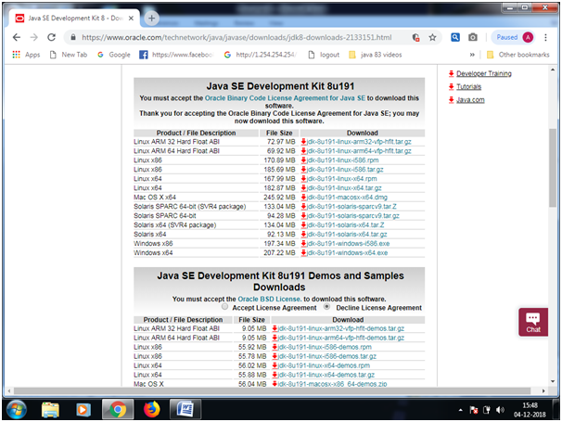

3. You can see the file downloaded in download folder.

4. Double click on the .exe file and click on Next , next till finish.

5. Verify that JDK is installed successfully in the below location

C:\Program Files\Java\jdk1.8.0_144\bin

**Question : What is the shortcut to verify that JAVA is installed in your system ?**

Ans : Open command Prompt and hit this command.

Java -version

Check below snapshot:

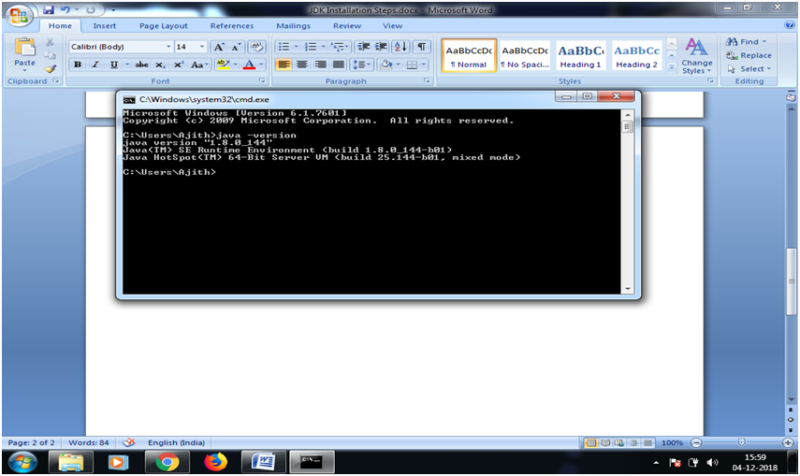

Download Eclipse Editor and to launch it, set the jdk path in system environment variable.

Question : How to set the path of JDK in System environment variable?

Answer :

Right click on Computer à click on Properties à click on Advanced System Settings à Under Advanced Tab ( this tab is selected by default), click on Environmental Variables à Under System variable section, select path (Variable name) and click on EDIT

In Variable Value textbox, go to the end, add a semicolon and copy and paste the below path.

C:\Program Files\Java\jdk1.8.0_144\bin

----------------------------------------------

How to create a JAVA project ?

1. Launch eclipse

2. File → New → Java Project

Enter a project name as shown below and click on Finish button.

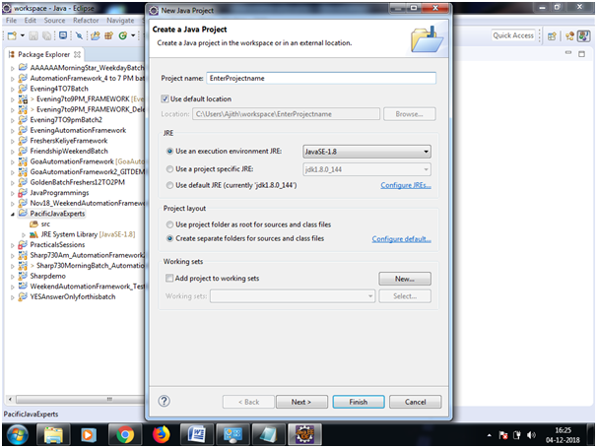

How to create a package under SRC folder ?

Right click on src → new → package

Enter a package name and click on Finish as shown below.

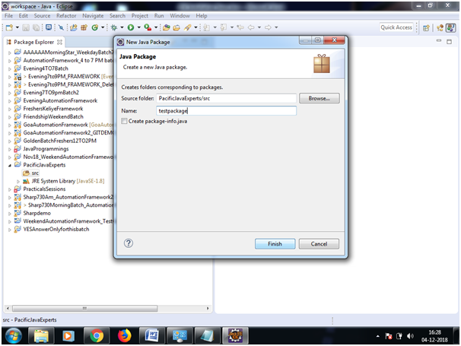

How to create a class ?

Right Click on the package → new → class

In the below window, enter a project name, select the checkbox – public static void main(Strings[] args) and click on Finish button.

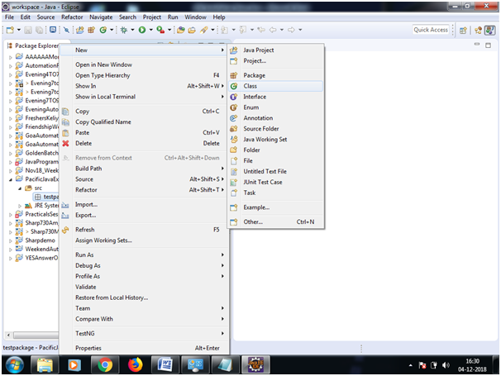

It will create a class as shown below.

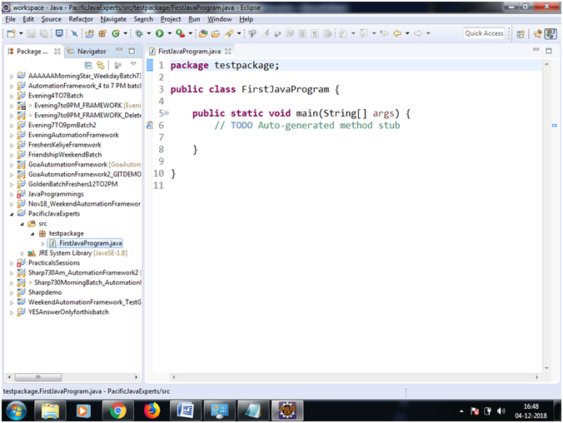

Where do we see the compiled .class file ?

Ans :

Under Navigator window pane → under the project → bin folder → package --> class file is present as shown below.

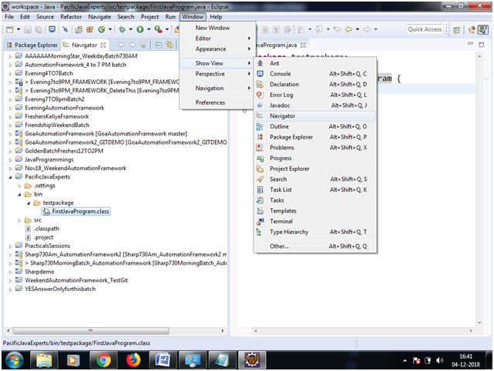

------------------------------------------------------------------------

**Question : What is a Class ?**

→ A class is a blueprint of a plan or a design.

→ It is a logical entity which can’t be touched or experienced. It doesn’t have any physical existence.

**Question : What is an Object ?**

→ Object is a physical entity which can be touched or experienced.

→ Object is also called as an instance of a class.

→ Object can be created out of a class.

→ Multiple objects can be created out a same class, we call these objects as identical objects or similar objects.

**Association :**

→ it is a phenomenon in java where in multiple objects are associated with a single owner object.

How many types of association do we have in java ?

Association are of 2 types:

→ Composition ( is also known Strong HAS-A relationship)

→ Aggregation ( is also known Weak HAS-A relationship)

**Question :** What is composition in java ?

→ It is a special form of association where in the associated objects can’t exists independently without the owner object. That is, if the owner object is destroyed, the associated objects will also be destroyed.

**Eg : 1. Water and the fish,**

Here, Water is the owner object, and fish is the associated object, Without water, fish can’t survive.

**2. Webpage ( Owner object ) with buttons ( associated objects).**

**3, Heart ( associated object ) and the human body ( Owner object).**

**4, Tree ( Owner object) and the leaves ( associated object ) ….Etc etc**

**Question :** What is **Aggregation** in java ?

→ It is a special form of association where in the associated objects can exists independently without the owner object. That is, if the owner object is destroyed, the associated objects will still be alive.

**Eg : Shoe ( Owner object ) and a lace ( associated object ),**

**Company ( Owner object ) and the employee ( associated object )**

**Car ( Owner object ) and the driver ( associated object )etc etc..**

-------------------------------------------------------------------------------------------------------

**Java Identifier :**

→ Identifier in java is the one which is used to identify any java member,

→ Java member can be the name of the class, the name of the variable or the name of the method.

**Rules of Identifier :**

→ Identifier should not have any space.

**Eg : public class Smart Phone {**

**// compilation error, class name can’t have a space.**

**}**

**class SmartPhone {**

**// No compilation error**

**}**

→ Identifier should not have any special characters except “**$” ( dollar )** and **“_”(underscore)**

**Eg :**

**public class Smart-Phone {**

**CE : // hyphen ( - ) is special character which is not allowed**

**}**

**class Smart_Phone {**

**// Underscore (_) can be used**

**}**

**3. Identifier should not start with a number.**

**Eg : public class 123SmartPhone {**

**// CE : Identifier should not start with numbers**

**}**

**class SmartPhone123 {**

**// We can have numbers as part of the identifier but not in the beginning.**

**}**

**4. Java reserved keywords should not be used as an identifier.**

**Eg :**

**public class int {**

**// CE : int is a reseverd keyword, can't be used as an identifier.**

**}**

**class try {**

**// CE : try is a reseverd keyword, can't be used as an identifier.**

**}**

***Interview Question :***

***Can we use a predefined class name or interface name as an identifier ?***

→ Name of a predefined class or interface in java can be used as an identifier, but we don’t use because it is not a good practice. Why ??

Because,

--> it creates confusion to the programmer,

→ it increases the complexity of the program,

→ it decreases the code readability.

**Eg :**

public class Collection {

// Collection is a predefined interface in java

}

class String {

// String is a predefined class in java

}

**------------------------------------------------------------------**

**Keywords :**

**What are keyword in java ?**

→ Keywords in java are something that has got a special meaning.

For eg :

If we want to store a numeric data, we use a keyword called “int”

If we want to store a character value, we use char keyword.

If we want to store a decimal value, we use either float or double keyword.

How many keywords we have in java ?

We have total 53 keywords in java.

→ Out of which, 3 are literals or constant value ( true, false, and null)

→ Out of remaining 50, we don’t use 2 keywords in java ( goto and const)

The list of 48 keywords are as follows.

Not neccessary

1. abstract -Specifies that a class or method will be implemented later, in a subclass
2. assert -Assert describes a predicate (a true–false statement) placed in a Java program to indicate that the developer thinks that the predicate is always true at that place. If an assertion evaluates to false at run-time, an assertion failure results, which typically causes execution to abort.
3. boolean – A data type that can hold True and False values only
4. break – A control statement for breaking out of loops
5. byte – A data type that can hold 8-bit data values
6. case – Used in switch statements to mark blocks of text
7. catch – Catches exceptions generated by try statements
8. char – A data type that can hold unsigned 16-bit Unicode characters
9. class -Declares a new class
10. continue -Sends control back outside a loop
11. default -Specifies the default block of code in a switch statement
12. do -Starts a do-while loop
13. double – A data type that can hold 64-bit floating-point numbers
14. else – Indicates alternative branches in an if statement
15. enum – A Java keyword used to declare an enumerated type. Enumerations extend the base class.
16. extends -Indicates that a class is derived from another class or interface
17. final -Indicates that a variable holds a constant value or that a method will not be overridden
18. finally -Indicates a block of code in a try-catch structure that will always be executed
19. float -A data type that holds a 32-bit floating-point number
20. for -Used to start a for loop
21. if -Tests a true/false expression and branches accordingly
22. implements -Specifies that a class implements an interface
23. import -References other classes
24. instanceof -Indicates whether an object is an instance of a specific class or implements an interface
25. int – A data type that can hold a 32-bit signed integer
26. interface – Declares an interface
27. long – A data type that holds a 64-bit integer
28. native -Specifies that a method is implemented with native (platform-specific) code
29. new – Creates new objects
30. package – Declares a Java package
31. private -An access specifier indicating that a method or variable may be accessed only in the class it’s declared in
32. protected – An access specifier indicating that a method or variable may only be accessed in the class it’s declared in (or a subclass of the class it’s declared in or other classes in the same package)
33. public – An access specifier used for classes, interfaces, methods, and variables indicating that an item is accessible throughout the application (or where the class that defines it is accessible)
34. return -Sends control and possibly a return value back from a called method
35. short – A data type that can hold a 16-bit integer
36. static -Indicates that a variable or method is a class method (rather than being limited to one particular object)
37. strictfp – A Java keyword used to restrict the precision and rounding of floating point calculations to ensure portability.
38. super – Refers to a class’s base class (used in a method or class constructor)
39. switch -A statement that executes code based on a test value
40. synchronized -Specifies critical sections or methods in multithreaded code
41. this -Refers to the current object in a method or constructor
42. throw – Creates an exception
43. throws -Indicates what exceptions may be thrown by a method
44. transient -Specifies that a variable is not part of an object’s persistent state
45. try -Starts a block of code that will be tested for exceptions
46. void -Specifies that a method does not have a return value
47. volatile -Indicates that a variable may change asynchronously
48. while -Starts a while loop

-----------------------------------------------------------------------------

**Question : How do you create an object of a class ?**

Ans : By using new keyword and the constructor of the class.

**Syntax :**

**<Class_Name> objectReferenceVariable = new <class_name>();**

**Eg :**

**//Class declaration :**

**public class Student {**

**}**

**Object Creation :**

**Student stdObj = new Student();**

**Here,**

**stdObj is the object reference variable.**

**What is object reference variable ?**

→ A variable which refers to an object in the heap memory is called object

Reference variable.

→ **new** is a keyword, using which, we can create an object of a class.

→ **Student()** -- is the constructor of the class.

**Question: who is responsible to create objects in java and where these objects get created ?**

→ JVM is responsible to create the object in java. These objects are created in

HEAP memory of RAM.

**Question : what are identical objects ?**

→ Multiple objects created out of a same class are known as identical objects.

--------------------------------------

**Java Variables :**

→ A variable is something that holds a value in the memory.

→ it refers to the name of the memory location.

→ it is always tagged with some or the other datatype.

Eg : int age = 30;

→ Here, age is the variable holding 30, and int is one of the primitive data type.

There are 3 types of variables :

→ local variable

→ instance variable

→ static variable

**Local Variable :**

→ A variable which is declared inside the method body is called local variable.

→ The scope of local variable is within the same method in which it is declared and initialized.

→ It is recommended to initialize the local variables at the time of declaration.

**Instance Variable :**

→ A variable declared in the class and outside the method is called instance variable.

→ Instance variable are specific to an instance of the class. That means, the value of instance variables will not be shared with other instance/object of the same class.

→ Instance variables are not declared as static.

**Static Variable :**

→ A variable declared as static is called static variable.

→ Static variable is a single copy created in memory and it can be shared by any number of instances/object of the same class.

Eg : public class VariableDemo

{

Int age = 27; // instance variable

Static String country = “India”; // Static variable

Public void m1()

{

Private double bankBalance = 99999.99; // local variable

}

}

---------------------------------------------------------------------------------------------------------------

Eg 2 :

**class** AddTwoNumbers{

**public** **static** **void** main(String[] args){

**int** a=10;

**int** b=10;

**int** c=a+b;

System.out.println(c);

}}

------------------------------------------------------------------------------------------------------------------

**Java Datatypes:**

→ It defines what type of data and the size of data that is stored in a variable.

There are 2 types of DataType in java :

→ Primitive datatype

→ Non primitive datatype

Primitive DataType :

→ There are 8 primitive datatype in java.

→ They are : boolean, char, byte, short, int, long, float and double

Non Primitive Datatype :

→ These datatypes are of Class type, interface type or array type.

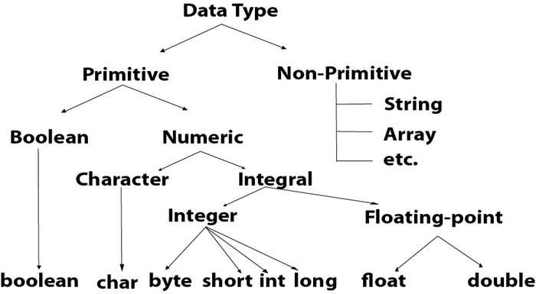

|  |  |  |
| --- | --- | --- |
| **Data Type** | **Default Value** | **Default size** |
| boolean | false | 1 bit |
| char | '\u0000' | 2 byte |
| byte | 0 | 1 byte |
| short | 0 | 2 byte |
| int | 0 | 4 byte |
| long | 0L | 8 byte |
| float | 0.0f | 4 byte |
| double | 0.0d | 8 byte |

## **‘boolean datatype :**

→ It allows only 2 values :: true and false

Eg: boolean isMarried = true;

**‘byte DataType :**

→ Its value-range lies between -128 to 127 (inclusive). Its minimum value is -128 and maximum value is 127. Its default value is 0.

**Example:** byte a = 10, byte b = -20

**‘Short DataType:**

→ Its value-range lies between -32,768 to 32,767 (inclusive). Its minimum value is -32,768 and maximum value is 32,767. Its default value is 0.

**Example:** short s = 10000, short r = -5000

**‘Int DataType :**

→ Its value-range lies between - 2,147,483,648 (-2^31) to 2,147,483,647

(2^31 -1) (inclusive). Its minimum value is - 2,147,483,648 and maximum value is 2,147,483,647. Its default value is 0.

**Example:** int a = 100000, int b = -200000

**‘Long DataType :**

→ Its value-range lies between -9,223,372,036,854,775,808(-2^63) to

9,223,372,036,854,775,807(2^63 -1)(inclusive). Its minimum value is -

9,223,372,036,854,775,808 and maximum value is

9,223,372,036,854,775,807. Its default value is 0. The long data type is used when you need a range of values more than those provided by int.

**Example:** long a = 100000L, long b = -200000L

**‘float DataType :**

→ Its value range is unlimited. It is recommended to use a float (instead of double) if you need to save memory in large arrays of floating point numbers. The float data type should never be used for precise values, such as currency. Its default value is 0.0F.

**Example:** float f1 = 234.5f

**‘double Datatype :**

→ Its value range is unlimited. The double data type is generally used for decimal values just like float. The double data type also should never be used for precise values, such as currency. Its default value is 0.0d.

**Example:** double d1 = 12.3

**‘char datatype :**

→ Its value-range lies between '\u0000' (or 0) to '\uffff' (or 65,535 inclusive).The char data type is used to store characters.

**Example:** char letterA = 'A'

**Java Fundamentals**

1. Identifiers

→ It refers to a name in java program.. It can be name of a class, or name of a variable or name of a method as well.

**Rules for defining the identifiers :**

→ Identifier should not start with digit, it should always starts with characters.

→ Identifiers are case sensitive.

→ Only 2 special characters can be used in the identifier. ( _ and $)

→ Reserved words can’t be used as identifiers.

Eg: int if = 20;

→ All java classes and interfaces name can be used as the name of the identifier, but it is not recommended, because it will decrease the readability of the code.

Eg : int String = 100; // No Compilation error

int Runnable = 200; // No Compilation error

**Interview questions :**

Which one are the valid java identifiers ?

**Total_number (valid)**

**total# ( Not valid - special character not allowed)**

**123total ( Not valid)**

**Total123 (valid)**

**ca$h (not valid)**

**_$_$_$_$ ( valid - these 2 special characters are allowed)**

**all@hands ( not valid - special character not allowed)**

**Java2share (valid)**

**Integer (valid but not recommended to use because these are class name)**

**Int (Valid)**

**int ( Not valid - keyword not allowed)**

--------------------------------------------------------------------

**Instance Variables:**

1. Instance Variables are the variables which should be created inside the class but outside the method, or block or constructor.

2. Instance variable gets loaded in the Heap memory once an object is created.

3. Instance variables are also known as non static variables or object level variables.

4. Instance variables are object specific. That is..If the data is different for different objects, then we declare instance variable.

5. Instance variables can’t be accessed directly from static area (eg : static method). But, these variables can be accessed by using object reference variable from static area.

6. Instance variables can be directly accessed from instance area (eg - instance method)

7. If the instance variables in one object is modified, it will not impact any other object, and hence these objects are independent of each other.

8. The scope of instance variable is same as the scope of the object. That is, once the object is destroyed, the life of instance variable will also be expired.

----------------------------------------------------------------------------------------

**Static Variables :**

1. Variables which are declared with static keyword are known as static variables.

2. These static variables must be created within the class but outside the method body or block or constructor.

3. Static variables get loaded in the memory (class area or static pool) once the class (.class file ) is loaded by JVM

4. Static variables are also known as class variables.

5. Static variables can be directly accessed from both static area and instance area.

6. Static variables should be accessed by using the class name. However, these variables can also be accessed by using the object reference variable, but it is not recommended.

7. If the static variable is modified, then all the referring objects will have the updated value, because, static means one single copy in the memory.

8. The scope of static variable is same as the scope of the class. That is, once the class is unloaded (--> due to JVM shutdown), the life of static variable will also be expired.

9. If we want common data to be shared across multiple objects, then we declare these data members as static variables.

--------------------------------------------------------------------------------------------------------------------------

**Local Variable :**

→ A variable which is declared inside the method body is called local variable.

→ The scope of local variable is within the same method in which it is declared and initialized.

→ It is recommended to initialize the local variables at the time of declaration.

-------------------------------------------------------------------------------------------------------------------------

**Program Eg:**

**package** testpackage;

**public** **class** Student{

String name;

**double** percentage;

**static** String *institue* = "Jspiders";

**public** **static** **void** main(String[] args) {

System.***out***.println("***Create object for student 1****");

Student studentObj1 = **new** Student();

System.***out***.println("******B4 assinging the value or default values****");

System.***out***.println(studentObj1.name);//Null

System.***out***.println(studentObj1.percentage);//0.0

System.***out***.println(Student.*institue*);//Jspiders

studentObj1.name = "Deepu Neeta";

studentObj1.percentage = 36;

System.***out***.println("******After assinging the value ****");

System.***out***.println(studentObj1.name);//deepu neeta

System.***out***.println(studentObj1.percentage);//36.0

System.***out***.println(Student.*institue*);//Jspiders

System.***out***.println(studentObj1.*institue*);//Jspiders

System.***out***.println("**********for arpita*************");

Student studentObj2 = **new** Student();

studentObj2.name = "Arpita";

studentObj2.percentage = 35;

System.***out***.println(studentObj2.name);//Arpita

System.***out***.println(studentObj2.percentage);//35.0

System.***out***.println(Student.*institue*);//Jspiders

System.***out***.println(studentObj2.*institue*);//Jspiders

System.***out***.println("**********changing the value of static variables*************");

*institue* = "Qspiders";

System.***out***.println(Student.*institue*);//Qspiders

System.***out***.println(studentObj1.*institue*);//Qspiders

System.***out***.println(studentObj2.*institue*);//Qspiders

}

}

----------------------------------------------------------------------------------

**Question : Explain System.out.println(“welcome to java”) ?**

--> It is used to print a custom value on the console.

→ Here, System is a predefined class in java.

--> ‘out is a static object reference variable in System class, which is pointing to an object of PrintStream class.

--> Println() is one of the non static method of PrintStream class which is actually responsible to print any custom value on the console.

----------------------------------------------------------------------------------------------------

**Array :**

* It is an index based collection of similar type of data.
* Can store only homogenous data.
* Data present in array are known as elements.
* Array index starts with zero.
* Arrays are fixed, that is, when we declare an array, we must define the size.
* We can store duplicate values.
* We can also store null values.
* We can store both the address of an object and the actual object itself.

**Array Declaration :**

→ Array can be declared in 2 ways.

1st Approach :

int[] arr = new int[4]; (--> int type array)

String[] arr = new String[4]; (→ String type array)

**Int Array Initialisation :**

‘arr[0] = 10;

‘arr[1] = 20;

‘arr[2] = 30;

‘arr[3] = 40;

‘arr[4] = 50; [Exception here :- ArrayIndexOutOfBoundsException]

**String Array Initialisation :**

‘arr[0] = “java”;

‘arr[1] = “python”;

‘arr[2] = “c#”;

‘arr[3] = “sql”;

‘arr[4] = “oracle”; [Exception here :- ArrayIndexOutOfBoundsException]

2nd  Approach of Array Declaration and Initialisation:

‘int[] arr = {10,20,30,40};

String[] arr = {“java”,”python”,”c#”,”sql”};

Question : How do you iterate in an array object ?

--> We can iterate in an array object by using either for loop or enhanced for loop.

*Eg1 : Using for loop, we can traverse in an array in forward direction.*

*‘for(int i = 0; i< arr.length;i++)*

*{*

*System.out.println(arr[i]);*

*}*

*--------------------------------------------------------------------------------------------------------------*

*Eg2 : Using for loop, we can also traverse in an array in backward direction.*

*‘for(int i = arr.length-1; i >= 0;i--)*

*{*

*System.out.println(arr[i]);*

*}*

*------------------------------------------------------------------------------------------------------------*

*Eg3 : Using for loop, we can traverse partially in an array.*

*‘for(int i = 3; i < arr.length-5;i ++)*

*{*

*System.out.println(arr[i]);*

*}*

*-------------------------------------------------------------------------------------------------------------*

**Array iteration using Enhanced for loop :**

Eg : Using enhanced for loop, we can traverse in an array ONLY in forward direction. Enhanced for loop doesn’t support backward and partial search.

*for(int i : arr)*

*{*

*System.out.println(i);*

*}*

//Here,

arr --> is the array object reference,

int → denotes what type of data does the array object holds

i --> is a variable

----------------------------------------------------

**Method :**

What is a method ?

Ans :

→ A method is a set of instructions or block of code which performs a specific task.

→ Method can return either primitive data or non primitive data.

→ Method can't return multiple primitive data types (eg : method can't return both int

and String at the same time).

→ But, It can return collection of homogeneous data type. ( eg : int[] array or String[]

array etc..)

----------------------------------------------------------------------------------------------------

**Demo program : Method returning a primitive data type**

public class CalculatorDemo {

//method to add 2 numbers

double add(double a, double b){

double c = a + b;

return c;

}

public static void main(String[] args) {

CalculatorDemo calc = new CalculatorDemo();

double res = calc.add(10.10, 20.20);

System.out.println("The addition of 2 number is : "+res);

}

}

----------------------------------------------------------------------------------------------------

**Demo program : Method returning a non primitive data type [ a class type data]**

public class **Water** {

void drink(){

System.out.println("drink water..and stay happy..");

}

}

public class **Tap** {

public Water openTap(){

Water w = new Water();

return w;

}

}

public class **Person** {

public static void main(String[] args) {

//Create an object of Tap class and call openTab() method.

Tap t = new Tap();

Water openTap = t.openTap();

openTap.drink();

}

}

**---------------------------------------------------------------------------------------------------------------**

**Demo Program : Method returning non primitive Array object**

Eg1 : A shop selling multi color pencils**.[method returning an array of pencils..]**

**Program :**

**Pencil.java :**

public class Pencil {

public String color;

void write(){

System.out.println("pencil writes in " + color);

}

}

**Shop.java**

public class Shop {

Pencil[] sell(){

//Creating an object of Pencil with Red color

Pencil p1 = new Pencil();

p1.color = "Red";

//Creating an object of Pencil with Blue color

Pencil p2 = new Pencil();

p2.color = "Blue";

//Creating an object of Pencil with Black color

Pencil p3 = new Pencil();

p3.color = "Black";

//Creating an Pencil array and storing the address of pencil objects

Pencil[] pArr = {p1,p2,p3};

//returning the pencil array object reference

return pArr;

}

}

**Kid.java**

public class Kid {

public static void main(String[] args) {

//Kids goes to the shop and buy pencils - create an shop object here.

Shop s = new Shop();

Pencil[] allPencils = s.sell();

//use Enhanced foreach loop to iterate with in the array elements.

for (Pencil pencil : allPencils) {

pencil.write();

}

}

}

**Output :**

*pencil writes in Red color*

*pencil writes in Blue color*

*pencil writes in Black color*

------------------------------------------------------------------------------------------------------------

Eg2 : A shop selling multi color flowers**[method returning an array of flowers..]**

Program :

/*

Do this as an assignment

*/

------------------------------------------------------------------------------------------------------------

**Method Syntax :**

<Access_modifier> <Return_Type> methodName(parameter1, parameter2,...)

{

//code -- method body or implementation or definition or logic

}

-----------------------------------------------------------------------------------------------------------

Why we use methods ?

Ans :

→ To achieve code reusability

→ For code optimisation

What is Method invocation or method call ?

Ans : Once we declare a method, it will not get executed on its own. We need to explicitly call or invoke the method, this process is known as method invocation or method call.

--------------------------------------------------------------------------------------------------------------------

**Program Demo : Initialisation of instance variables using methods**

public class **Account** {

int acc_no;

String accHolderName;

double amount;

void openAccount(int i, String s, double d){

acc_no = i;

accHolderName = s;

amount = d;

}

void displayAccountInfo(){

System.out.println("Account is created below");

System.out.println("Account number --> "+acc_no + " \n "+ "Account holder Name -->" + accHolderName+ " \n " + "Initial Amount -->"+ amount);

}

void checkBalance(){

System.out.println("Available balance is : "+amount);

}

void deposit(double depositAmt){

amount = amount + depositAmt;

System.out.println("Amount Deposited :" + depositAmt);

}

void withdraw(double withdrawAmt){

if (withdrawAmt > amount) {

System.out.println("Insufficient balance...");

} else {

amount = amount - withdrawAmt;

System.out.println("Amount Withdrawn : " + withdrawAmt);

}

}

public static void main(String[] args) {

Account acc = new Account();

acc.openAccount(111, "Smrithi", 1000);

acc.displayAccountInfo();

acc.checkBalance();

acc.deposit(9000);

acc.checkBalance();

acc.withdraw(10000);

acc.checkBalance();

}

}

**Output :**

*Account is created below*

*Account number --> 111*

*Account holder Name -->Smrithi*

*Initial Amount -->1000.0*

*Available balance is : 1000.0*

*Amount Deposited :9000.0*

*Available balance is : 10000.0*

*Amount Withdrawn : 10000.0*

*Available balance is : 0.0*

----------------------------------------------------------------------------------------------------------------------

**Conditional statement :**

If we want to execute a set of statement based on a condition, then we go for conditional

statements.

**If -else if :--**

Problem Statement :

→ If the age of a person is less than 18 -- treat him as a kid

→ If the age of a person is (greater than or equal to 18 ) AND (less than or equal to 59) -- treat him as a Adult

→ If the age of a person is (greater than or equal to 60) AND (less than or equal to 120) -- treat him as a Senior Citizen

→ If the age of person is greater than 120, he is expired.

public class If_ElseIf_Example {

public static void main(String[] args) {

Scanner sc = new Scanner(System.in);

System.out.println("Enter the age..");

int age = sc.nextInt();

if (age<18) {

System.out.println("Kid's Age is :--> "+age);

} else if(age >=18 && age<=59)

{

System.out.println("Adult age is :-->" + age);

}else if(age>=60 && age <=120){

System.out.println("Senior Citizen age is :-->"+age);

} else{

System.out.println("He is expired...");

}

}

}

----------------------------------------

Problem Statement :

Print the month based on user input.

eg : 1 -- january, 2 -- february .. 12 -- dec, greater than 12 - month doesn't exists

using if-elseif :

public class If_ElseIf_Example {

public static void main(String[] args) {

//Alt + Shift + R -- short cut to rename a variable at multiple places

Scanner sc = new Scanner(System.in);

System.out.println("Enter the month..");

int month = sc.nextInt();

if (month==1) {

System.out.println(month + " --> January");

} else if(month==2)

{

System.out.println(month + " --> February");

}else if(month==3){

System.out.println(month + " --> March");

} else if(month==4)

{

System.out.println(month + " --> Apr");

}else if(month==5){

System.out.println(month + " --> May");

} else if(month==6)

{

System.out.println(month + " --> June");

}else if(month==7){

System.out.println(month + " --> July");

} else if(month==8)

{

System.out.println(month + " --> August");

}else if(month==9){

System.out.println(month + " --> Sept");

} else if(month==10)

{

System.out.println(month + " --> Oct");

}else if(month==11){

System.out.println(month + " --> Nov");

} else if(month==12)

{

System.out.println(month + " --> Dec");

}else{

System.out.println("Month doesn’t exists..");

}

}

}

Drawback of If-else-if ladder :

→ If we deal with lots of conditions, if else if ladder is not recommended, because it doesn’t provide code readability. So, in this case, we should go for switch case which provides code readability.

--------------------------------------------------------------------------------------------------------

**using switch- case :**

public class SwitchCaseExample {

public static void main(String[] args) {

Scanner sc = new Scanner(System.in);

System.out.println("Enter month number.. 1 -- Jan , 2 -- Feb...so on");

int monthNum = sc.nextInt();//CTRL + 1 + ENTER

switch(monthNum){

case 1:

System.out.println(monthNum + " --> January");

break;

case 2:

System.out.println(monthNum + "--> Feb");

break;

case 3:

System.out.println(monthNum + "--> Mar");

break;

case 4:

System.out.println(monthNum + "--> Apr");

break;

case 5:

System.out.println(monthNum + "--> May");

break;

case 6:

System.out.println(monthNum + "--> June");

break;

case 7:

System.out.println(monthNum + "--> July");

break;

case 8:

System.out.println(monthNum + "--> Aug");

break;

case 9:

System.out.println(monthNum + "--> Sept");

break;

case 10:

System.out.println(monthNum + "--> Oct");

break;

case 11:

System.out.println(monthNum + "--> Nov");

break;

case 12:

System.out.println(monthNum + "--> Dec");

break;

default:

System.out.println("Month doesn’t exists.. enter a valid month");

break;

}

}

}

------------------------------------------------------------------------------------------------------------

**While loop:**

→ when we want a set of statement to be executed multiple times based on a condition, we use while loop.

→ If the condition is true, then only the set of statements inside the while loop will be executed.

→Control will come out of the while loop, if the condition turned out to be false.

→ If the condition is never true, it will never execute the while loop statements.

Why we go for loop ?

-- to optimize the code

-- to increase the code readability.

-- to decrease the code complexity

Syntax :

while(condition)

{

//code

}

Program example1 :

Problem statement : Print 1 to 10 number.

public class WhileLoopDemo {

public static void main(String[] args) {

int x = 1;

while(x <= 10){

System.out.println(x);

x++;

}

}

}

----------------------------------------------------------------------------------------------------------------

Program example2 :

Problem statement : Iterate using while loop for 10 times, if the number is 5, come out of the loop.

public class WhileLoopDemo {

public static void main(String[] args) {

int x = 1;

while(x <= 10){

if (x == 5) {

System.out.println(x);

break;

}

x++;

System.out.println("****inside the while loop*****");

}

System.out.println("****outside the while loop*****");

}

}

--------------------------------------------------------------------------------------------------------------------

**do while loop :**

→ Whether the condition in do while loop is true or false, it will execute the statements atleast once.

→ it will execute the statements till the condition is true. and will come out of the loop, once the condition becomes false.

----------------------------------------------------------------------------------------------------------------------

**Syntax :**

do

{

// code or statements

}while(condition);

----------------------------------------------------------------------------------------------------------------------

Program Example 1:

public class DoWhileLoopDemo {

public static void main(String[] args) {

int x = 1;

do {

System.out.println(x);//1

x = x + 1;

} while (x > 10);

}

}

O/p == 1

----------------------------------------------------------------------------------------------------------------------

Program Example 2 :

public class DoWhileLoopDemo {

public static void main(String[] args) {

int x = 1;

do {

System.out.print(x + " ");

x = x + 1;

} while (x <= 10);

}

}

O/p --> 1 2 3 4 5 6 7 8 9 10

----------------------------------------------------------------------------------------------------------------------

**Question : When do we go for while loop and do while loop ?**

→ We go for while loop, when we want to execute a set of statements only and only if the condition is true.

→ And, we go for do while loop, if we want to execute a set of statements atleast once, irrespective of the condition being true or false.

-------------------------------------------------------------------------------------------------------------------

**What is method overloading ?**

The concept of having multiple methods in a class with the same name but different in

Parameters is called method overloading.

OR

Performing similar tasks with different inputs is called method overloading.

--------------------------------------------------------------------------------------------------------------------

Rules of method overloading :-

1. The method name must be same.

2. The number of parameters must be different.

3. The datatype of parameters must be different.

4. The sequence of parameters must be different

-------------------------------------------------------------------------------------------------------------------------

Question : Does the method return type play any role in Method Overloading ?

No. Method return type doesn’t play any role in method overloading. It can be same or different.

Question : What is method signature ?

Ans : Method signature includes method name and parameter list.

Question : Why method overloading ?

Ans:

1. To reduce the complexity of the program.

2. To increase the readability of the program.

3. To achieve compile time polymorphism.

Question : What is compile time polymorphism ?

→ The process of compiler taking a decision as to which method implementation to be executed during compile time is called compile time polymorphism.

→ It is also known as Early binding or static binding.

Question: Why compile time polymorphism is known as early binding ?

Ans :

Because compiler binds a method call with a method definition at an early stage right before the program execution, and hence, we call compile time polymorphism as early binding.

Example 1:

public class MethodOverloadingDemo {

void display(int i){

System.out.println(i);

}

void display(String s){

System.out.println(s);

}

void display(double d){

System.out.println(d);

}

void display(boolean b){

System.out.println(b);

}

public static void main(String[] args) {

MethodOverloadingDemo m = new MethodOverloadingDemo();

m.display(10.50);

m.display(10);

m.display("java");

m.display(true);

}

}

Output

*10.5*

*10*

*java*

*true*

-------------------------------------------------------------------------------------------------------------------

**Example 2 :**

public class MethodOverloadingDemo {

void add(int a, int b){

System.out.println("Sum of 2 int values --> " +(a+ b));

}

void add(double a, double b){

System.out.println("Sum of 2 double values --> " +(a + b));

}

void add(int a, double b){

System.out.println("Sum of 1 int and 1 double value --> " +(a+ b));

}

void add(double a, int b){

System.out.println("Sum of 1 double and 1 int value --> " +(a + b));

}

public static void main(String[] args) {

MethodOverloadingDemo m = new MethodOverloadingDemo();

m.add(10, 20);

m.add(10.10, 20.20);

m.add(10, 10.10);

m.add(10.10, 20);

}

}

Output :

*Sum of 2 int values --> 30*

*Sum of 2 double values --> 30.299999999999997*

*Sum of 1 int and 1 double value --> 20.1*

*Sum of 1 double and 1 int value --> 30.1*

---------------------------------------------------------------------------------------------------------------------------

Type Promotion : (In case of primitive data type)

The process of automatic conversion of lower data type in to higher data type by the compiler is called type promotion.

Type promotion - program example :

public class TypePromotionExample {

void add(double a, double b){

System.out.println("Type promotion by the compiler --> " +(a + b));

}

public static void main(String[] args) {

TypePromotionExample m = new TypePromotionExample();

m.add(10, 20);

}

}

Output:

*Type promotion by the compiler --> 30.0*

--------------------------------------------------------------------------------------------------------------------------

Type casting (In case of primitive data type)

The process of conversion of higher data type in to lower data type explicitly by the user is called type casting.

Program example:

public class TypeCastingExample {

public static void main(String[] args) {

int a = (int) 10.10;

System.out.println(a);

}

}

Output

*10*

------------------------------------------------------------------------------------------------------------------------

Question : What is method dispatch or method resolution ?

Ans :

The process of binding a method call with a method definition by the compiler is called method dispatch or method resolution.

-------------------------------------------------------------------------------------------------------------------------

**What is a constructor ?**

A constructor is a special method which is used to initialise the instance variables at the time of object creation.

Question : When does the constructor gets called ?

Ans : Constructor gets called at the time of object creation.

Constructor Syntax :

<Class_Name>()

{

}

→ Constructor name must be same as the class name.

→ Constructor doesn’t have a return type, not even void.

Question : How many type of constructor we have ?

There are 2 types of constructors.

→ Default Constructor

→ Custom Constructor

Question : Explain Default Constructor ?

Ans:

→ When user don’t define any constructor, compiler provides a default constructor.

→ Default constructor is used to initialize the instance variable to its default values based on

the data type.

→ Default constructor will not have any parameter. It is a zero-param constructor or no-arg

Constructor.

→ The access modifier of default constructor is same as that of the class.

Question : Explain Custom Constructor ?

Ans:

→ User defined constructor is also known as custom constructor.

→ Custom constructor can be either zero-param constructor or parameterised constructor.

→ Custom constructor is used to initialize the instance variable to user defined values.

→ The access modifier of custom constructor can be either public or protected or default or

Private.

Question : What is a zero-param constructor or no-arg constructor ?

Ans:

A constructor with no parameter is called a zero-param constructor.

Question : What is a parameterised constructor ?

Ans:

An user defined constructor with any number of parameters is called a parameterised constructor.

Question : What does a constructor returns ?

Ans : It returns an instance of the same class. (However, it does not have any return type.)

**Question : What is constructor overloading ?**

The concept of having more than one constructor in a class with different parameter list is called constructor overloading.

**Question : Why constructor overloading ?**

It provides a flexibility to create different objects based on the requirement.

Rules for constructor Overloading :

1. Constructor name must be same as the class name.

2. Number of parameters must be different.

3. Data type of the parameters must also be different.

4. Sequence of parameters must be different.

Example of Overloaded Constructor :

Program :

public class Car {

String brand;

double price;

int model;

Car(){

}

Car(String b, double p){

brand = b;

price = p;

}

Car(String b, double p, int m) {

brand = b;

price = p;

model = m;

}

public void display(){

System.out.println(brand + " : "+ price + " :" + model);

}

public static void main(String[] args) {

Car c1 = new Car("Audi", 9999999.99);

Car c2 = new Car();

Car c3 = new Car("Rolls Royce", 999, 2018);

c1.display();// Audi : 9999999.99

c2.display();//null :0.0

c3.display();//"Rolls Royce", 9999999999999999999.99, 2018

}

}

**Output :**

*Audi : 9999999.99 :0*

*null : 0.0 :0*

*Rolls Royce : 999.0 :2018*

---------------------------------------------------------------------------------------------------------------------------

**Inheritance :**

**Question : What is inheritance ?**

Ans:

→ Inheritance is the process of acquiring all the properties and behaviours of one class in

to another class.

→ Inheritance is also known as IS-A relationship

→ We can achieve inheritance by using extends keyword.

**Question : What is a parent class ?**

→ Class with all generic or common properties or behaviours is called parent class.

→ Parent class is also known as Super class or Base class or Generic class.

**Question : What is a child class ?**

→ A class that extends a parent class is called child class.

→ Child class is also known as Sub class or Derived class or Extended class.

**Question : Why inheritance ?**

→ To achieve code reusability.

→ to achieve generalisation.

→ to achieve runtime polymorphism.

**---------------------------------------------------------------------------------------------------------**

**What are the different types of inheritance ?**

There are 5 types of inheritance.

*→ Single inheritance [Simple inheritance]*

*→ Multi Level Inheritance*

*→ Hierarchical inheritance*

*→ Multiple Inheritance*

*→ Hybrid Inheritance*

**→ Single inheritance [Simple inheritance]**

These is a type of inheritance where in one class inherits all the properties of another class.

Eg :

1. Class System extends Object
2. Class String extends Object

**→ MultiLevel Inheritance**

This is a type of inheritance where in one class acts as both subclass and superclass.

**Eg :**

**Object**

**| extends**

**Number**

**| extends**

**Integer**

Here, ( Number class is sub class of Object class and at the same time, it is a super class to Integer class)

**→ Hierarchical inheritance**

This is a type of inheritance where in one super class is inherited by multiple subclasses.

Eg :

**Object**

**| extends | extends**

**Number String**

**OR**

**Number**

**| extends**

**Integer Double Float**

**→ Multiple Inheritance**

This s a type of inheritance where in one sub class inherits more than one super class.

[Multiple inheritance is not possible in case of class]

**Question : Why multiple inheritance in case of class is not possible in java ?**

Ans:

1. Because of ambiguity in method invocation between 2 super classes.
2. And, it also creates an ambiguity as to which super class constructor to be invoked.

→ Hybrid Inheritance

Hybrid inheritance is a combination of 2 or more types of inheritance.

[eg : Single inheritance + multilevel inheritance + hierarchical inheritance etc]

**---------------------------------------------------------------------------------------------------------**

**What is Run time polymorphism ?**

Ans:

The process of JVM taking a decision as to which method implementation to be executed at run time based on the object created is called run time polymorphism.

Program :

**Pen.java [Parent class]**

public class Pen {

void write(){

System.out.println("Enjoy writing...");

}

}

---------------------------------------------------------------------------------------------------------------------------

**InkPen.java [Child Class]**

public class InkPen extends Pen{

}

---------------------------------------------------------------------------------------------------------------------------

**MarkerPen.java[Child Class]**

public class MarkerPen extends Pen{

}

---------------------------------------------------------------------------------------------------------------------------

**SketchPen.java[Child Class]**

public class SketchPen extends Pen{

}

---------------------------------------------------------------------------------------------------------------------------

**PenFactory.java**

public class PenFactory {

public static Pen getPen(String penType){

Pen p = null;

if (penType.equalsIgnoreCase("ink")) {

p = new InkPen();

System.out.println("ink pen block");

} else if(penType.equalsIgnoreCase("sketch")){

p = new SketchPen();

System.out.println("sketch pen block");

} else if(penType.equalsIgnoreCase("marker")){

p = new MarkerPen();

System.out.println("marker pen block");

}

return p;

}

}

---------------------------------------------------------------------------------------------------------------------------

**Customer.java**

public class Customer {

public static void main(String[] args) {

System.out.println("Enter the type of Pen which you want {'ink','sketch', 'marker'}");

Scanner sc = new Scanner(System.in);

String penType = sc.next();

System.out.println("Customer want this type of pen :--> "+penType);

Pen penObj = PenFactory.getPen(penType);

if (penObj != null) {

penObj.write();

} else {

System.out.println("We don’t sell this type of pen..");

}

}

}

**Output :**

*Enter the type of Pen which you want {'ink','sketch', 'marker'}*

*ink*

*Customer want this type of pen :--> ink*

*ink pen block*

*Enjoy writting...*

--------------------------------------------------------------------------------------------------------------------------

**What is Upcasting ?**

Ans :

It is a mechanism where in a superclass reference refers to a sub class object to achieve generalisation.

OR

Creating an object of sub class and referring it by super class reference variable is called upcasting.

**Program example :**

**Create a super class - Fruit.java**

public class Fruit {

void eat(){

System.out.println("Eat fruit - and stay healthy..");

}

}

**Create a sub class - Apple.java**

public class Apple extends Fruit{

@Override

void eat() {

System.out.println("One apple a day - keep the doctor away..");

}

}

**Create another sub class - Banana.java**

public class Banana extends Fruit{

@Override

void eat() {

System.out.println("One banana a day - keep your muscles healthy");

}

}

**Customer.java**

public class Customer {

public static void main(String[] args) {

Fruit f = new Apple();// Super class [Fruit] reference pointing to sub class object[Apple]

f.eat();//

f = new Banana();// Super class [Fruit] reference pointing to sub class object[Banana]

f.eat();//

}

}

**Output :**

*One apple a day - keep the doctor away..*

*One banana a day - keep your muscles healthy*

--------------------------------------------------------------------------------------------------------------------------

What is method overriding ?

Ans :

Method overriding is the process of providing specific implementation to sub class method.

Rules of method overriding ?

→ Method overriding is possible only in case of inheritance.

→ Method name must be same in both super and sub class.

→ The number of parameters must be same.

→ The data type of parameters must be same

→ The sequence of parameters must be same.

→ Method return type must be same in case of primitive data. But in case of non primitive data type, method return type can be changed.

What is overridden method and overriding method ?

Super class method is overridden by subclass method, hence we call super class method as overridden method.

Sub class method overrides super class method, hence we call subclass method as overriding method.

Method Overriding - Program example :

Create Base class - Bank.java

public class Bank {

void getRateOfInterest(){

System.out.println(“interest free .. ");

}

}

Create a Derived class - Citi.java

public class Citi extends Bank{

@Override*// Providing specific implementation to sub class method*

void getRateOfInterest() {

System.out.println("Rate of interest is 15.75%");

}

}

Create a Derived class - Sbi.java

public class SBI extends Bank {

@Override *// Providing specific implementation to sub class method*

void getRateOfInterest() {

System.out.println("Rate of interest is 8.8%");

}

}

Customer goes to a bank and apply for a loan - TakeLoan.java

public class TakeLoan {

public static void main(String[] args) {

Bank b = new Citi();

b.getRateOfInterest();

b = new SBI();

b.getRateOfInterest();

}

}

Output :

*Citi bank - Rate of interest is 15.75%*

*SBI bank - Rate of interest is 8.8%*

-------------------------------------------------------------------------------------------------------------------

**Question : What is instanceof keyword in java ?**

It checks whether an object reference is of the specified class or interface type. If it is of the same type, it returns true and if it is not of the same type, it returns false.

Dog d = new Dog();

Cat c = new Cat();

SOP(d instanceof Dog); // output is TRUE

SOP(c instanceof Cat); // output is TRUE

SOP(d instanceof Cat); // output is FALSE

SOP(c instanceof Dog); // output is FALSE

------------------------------------------------------------------------

**COVARIANT RETURN TYPE:**

It is a mechanism where in the return type of sub class method can be same as that of the super class method or it can be changed to any of its subclass type is called co-variant return type.

*Note :*

*in case of primitive data type*, t*he return type of sub class method must be same as that of the super class method.*

**Program Example :**

**Food.java**

public class Food {

}

**VegFood.java**

public class VegFood extends Food{

}

**NonVegFood.java**

public class NonVegFood extends Food{

}

**NorthIndianFood.java**

public class NorthIndianFood extends VegFood{

}

**SouthIndianFood.java**

public class SouthIndianFood extends VegFood{

}

**CholeBatura.java**

public class CholeBatura extends NorthIndianFood{

}

**PuriSabji.java**

public class PuriSabji extends NorthIndianFood{

}

**Idly.java**

public class Idly extends SouthIndianFood{

}

**Upma.java**

public class Upma extends SouthIndianFood{

}

**FatherHotel.java**

public class FatherHotel {

VegFood serve(int choice){

switch(choice){

case 1:

return new CholeBatura();

case 2:

return new PuriSabji();

case 3:

return new Idly();

case 4:

return new Upma();

default :

return null;

}

}

}

**Customer.java [When father is in the hotel]**

public class Customer {

public static void main(String[] args) {

FatherHotel f = new FatherHotel();

Scanner sc = new Scanner(System.in);

System.out.println("Enter your choice..\n 1. Chole Batora..\n 2. Poori Sabji"

+ "\n 3. Idly..\n 4. Upma");

int choice = sc.nextInt();

VegFood vf = f.serve(choice);

if (vf == null) {

System.out.println("Item not available");

} else {

if (vf instanceof CholeBatura) {

System.out.println("Enjoy chole batura..");

} else if (vf instanceof PuriSabji){

System.out.println("enjoy puri sabji with chatni..");

} else if(vf instanceof Idly){

System.out.println("suffer with Idly..");

}else{

System.out.println("Die with Upma..");

}

}

}

}

Output :

*Enter your choice..*

*1. Chole Batora..*

*2. Poori Sabji*

*3. Idly..*

*4. Upma*

*User enter a choice → 1*

*Enjoy chole batura..*

**Scenario : Now Son inherits Father’s business, but he serves only the North Indian food and not south indian food.**

**SonHotel.java**

public class SonHotel extends FatherHotel {

@Override

NorthIndianFood serve(int choice) {

switch(choice){

case 1:

return new CholeBatura();

case 2:

return new PuriSabji();

default:

return null;

}

}

}

**Customer.java [When Son is in the hotel]**

public class Customer {

public static void main(String[] args) {

SonHotel s = new SonHotel();

Scanner sc = new Scanner(System.in);

System.out.println("Enter your choice..\n 1. Chole Batora..\n 2. Poori Sabji");

int choice = sc.nextInt();

NorthIndianFood vf = s.serve(choice);

if (vf == null) {

System.out.println("Item not available");

} else {

if (vf instanceof CholeBatura) {

System.out.println("Enjoy chole batura..");

} else if (vf instanceof PuriSabji){

System.out.println("enjoy puri sabji with chatni..");

}

}

}

}

**Output :**

*Enter your choice..*

*1. Chole Batora..*

*2. Poori Sabji*

*User enter a choice → 2*

*enjoy puri sabji with chatni..*

*User enter a choice → 4*

*Item not available*

--------------------------------------------------------------------------------------------------------------------------

**Question : What is Constructor Chaining :**

→ It is a mechanism where in we call one constructor from another constructor.

**Rules of Constructor chaining ?**

→ Constructor call should be invoked from a constructor only. [We can’t call a constructor from any method or a block].

→ Constructor calling statement must be the first line of executable code within a constructor.

→ Only one constructor can be called from a given constructor.

**Question : What is this() and super() ?**

→ this() is a constructor calling statement which is used to call the current class constructor

Ji.njs,e → where as super() constructor calling statement which is used to call the immediate super class constructor.

**Question : Advantage of Constructor Chaining ?**

→ it enhances code reusability

→ it is used for code optimisation [it reduces the number of lines of code]

→ it increases the code readability

--------------------------------------------------------------------------------------------------------------------------

**What is this keyword ?**

→ this is a keyword which refers to current class object.

→ this keyword can be used to access any instance members. [may be instance variables or instance methods]

→ this keyword must be called from either a constructor body or an instance method.

--------------------------------------------------------------------------------------------------------------------------

**What is super keyword ?**

→ super is a keyword which refers to immediate super class object.

→ super keyword can be used to access any instance members of super class. [may be instance variables or instance methods]

→ super keyword must be called from either a constructor body or an instance method.

--------------------------------------------------------------------------------------------------------------------------

**Difference between method and constructor ?**

|  |  |
| --- | --- |
| **Method** | **Constructor** |
| The name of the method need not be same as that of the class name. It can be any name as long as it is meeting up the rules of identifiers. | The name of the constructor must be same as that of the class name. |
| Methods are used to perform a specific task . that is it exposes the behaviour of an object. | **C**onstructors are used to instantiate an object. |
| Methods must be invoked explicitly. | Constructors are invoked implicitly at the time of object creation. |
| **M**ethods can return either primitive or non primitive data. | Constructor does not have any return type - not even void. |
| Methods can be inherited and hence, can be overridden. | Constructor can’t be inherited and hence, can’t be overridden. |
| Methods can be either static or non static. | Constructor can’t be static |

--------------------------------------------------------------------------------------------------------------------------

**What is an Anonymous object in java ?**

→ An object without any reference is called anonymous object. We also call this object as dereferred object. Such objects are eligible for garbage collection.

--------------------------------------------------------------------------------------------------------------------------

**Question : What is object instantiation ?**

→ The process of assigning values to instance variables of an object is called instantiation of an object.

--------------------------------------------------------------------------------------------------------------------------

**What is a package ?**

→ It is a group of similar type of classes or interfaces or sub-packages.

---------------------------------------------------------------------------------------------------------------------------

**How many types of package do we have ?**

→ There are 2 types of packages in java.

→ Inbuilt package ( Predefined package)

→ User defined package (**Custom** package)

---------------------------------------------------------------------------------------------------------------------------

**What are Inbuilt package in java ?**

→ Package which is already created by java community are known as inbuilt package.

→ All predefined packages are inbuilt packages.

---------------------------------------------------------------------------------------------------------------------------

Any example of inbuilt packages ?

*→ java*

*→lang* ***[ It is the default package in java ]***

*→ io*

*→ util*

*→ awt*

*→ net*

*→ swing*

---------------------------------------------------------------------------------------------------------------------------

Question : Why we call java.lang as the default package in java ?

→ Because, we don’t have to import this package explicitly in order to access any of its resources.

---------------------------------------------------------------------------------------------------------------------------

Question : What are user defined package ?

→ The package which is created by the user is called user defined package or custom package.

---------------------------------------------------------------------------------------------------------------------------

Question : How do you create an user defined package ?

→ By using a keyword called ***package.***

Syntax : Package <package_name>

---------------------------------------------------------------------------------------------------------------------------

Question : What is the naming convention to define a package ?

→ ***domain.company.application.module***

Eg : com.google.gmail.inbox

com.google.gmail.sentitems

---------------------------------------------------------------------------------------------------------------------------

* Question : How do you access any resource from another package ?

→ In order to access any resources from another package, we first have to import.

---------------------------------------------------------------------------------------------------------------------------

How many ways of importing any resources ?

→ There are 3 ways of importing any resources.

1. Importing a specific class or interface
2. Importing all the classes or interfaces by using star ( *)
3. By specifying the fully qualified name of the class or interface

---------------------------------------------------------------------------------------------------------------------------

Example :

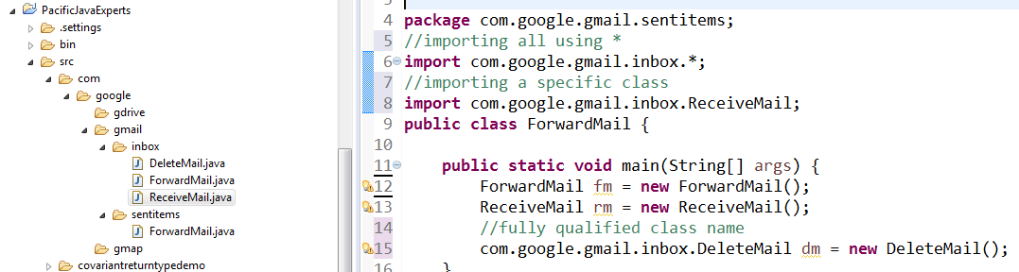

---------------------------------------------------------------------------------------------------------------------------

**Why do we go for package ?**

→ It provides easy data access and manipulation.

→ it provides access protection.

→ it avoids naming collisions.

→ it helps us in achieving modularity in the application.

**Access modifier:**

------------------------------------------------------------------------------------------------------------------------

Question : What is accessed modifiers ?

1. Ans : Access modifiers are something that defines the accessibility level of any java gx. Here, java members can be a class, or an interface, or a variable, a method or a constructor.

------------------------------------------------------------------------------------------------------------------------

Question : How many types of access modifiers do we have in java ?

There are 4 types of access modifiers in java. They are

→ public

→ protected

→ default

→ private

------------------------------------------------------------------------------------------------------------------------

Question : Describe the accessibility level of each access modifier ?

→ public : have the highest visibility

→ protected : have higher visibility than default

→ default : have lower visibility than protected

→ private : have the lowest visibility

------------------------------------------------------------------------------------------------------------------------

Private Access Modifier :

→ We can’t declare a class as private. Until unless it is an inner class [nested class]

→ Private variables and methods must be accessed within the same class,

class Father {  
 private double accBal = 9999.00;  
 private void smoke(){  
 System.out.println("I am a chain smoker, my son should not know..");  
 }  
 public static void main(String[] args) {  
 Father f = new Father();  
 System.out.println(f.accBal);  
 f.smoke();  
 }  
}

→ Private variables and methods can’t be accessed outside the class.

Example :  
public class Son extends Father{  
 public static void main(String[] args) {  
 Father f = new Father();  
 //Private members can't be accessed outside the class  
 f.accBal;//CE  
 f.smoke();//CE  
 }  
}  
→ Private constructor can’t be accessed outside the class.

→ If we want to stop someone to create an object of a class, declare the constructor as private.

*[Note : Object can be created with in the same class if it has a private constructor]*Program Example :  
class Father {  
 private double accBal = 9999.00;  
 private void smoke(){  
 System.out.println("I am a chain smoker, my son should not know..");  
 }  
 private Father() {  
 // this is the constructor  
 }  
}

public class Son {

public static void main(String[] args) {

//Private constructor can't be accessed outside

//We can't create an object of a class if it has a private constructor

Father f = new Father();//CE

}

}

------------------------------------------------------------------------------------------------------------------------

Default access modifier :

If we don’t set any java member with either public or protected or private, then it is set to default level. Default access modifier is within the package level.

1. A default java member must be accessed with in the same package only. It can't be accessed outside the package.

Program example :

package accessmodifiers1;

class Father {

}

package accessmodifiers2;

import accessmodifiers1.Father;//CE

public class Son {

public static void main(String[] args) {

Father f;//CE

}

}

---------------------------------------------------------------------------------------------------------------------------Scenario : Default variable , default method and default constructor can't be accessed outside the package.

Example :

package accessmodifiers1;

public class Father {

double accBal = 9999.00;

void smoke(){

System.out.println("I am a chain smoker, my son should not

know..");

}

Father() {

// this is the constructor

}

}

package accessmodifiers2;

import accessmodifiers1.Father;

public class Son {

public static void main(String[] args) {

Father f = new Father();//CE

System.out.println(f.accBal);//CE

f.smoke();//CE

}

}

Important Note : Default members can't be accessed even from any of its sub-packages.

------------------------------------------------------------------------------------------------------------------------

Public access modifier.

1. Any java member declared with public keyword is public java member.

2. A public member can be accessed from anywhere within the same project or from outside the project as well.

Program example :

Scenario :

Public class, public variable, public methods and public constructor can be

accessed outside the package anywhere with in the project.

package accessmodifiers1;

public class Father {

public double accBal = 9999.00;

public void smoke(){

System.out.println("I am a chain smoker, my son should not know..");

}

public Father() {

// this is the constructor

}

}

package accessmodifiers2;

import accessmodifiers1.Father;

public class Son {

public static void main(String[] args) {

Father f = new Father();

System.out.println(f.accBal);

f.smoke();

}

}

Output:

9999.0

I am a chain smoker, my son should not know..

---------------------------------------------------------------------------------------------------------------------------

Question :How do you access a public member from outside the package ?

By using import statements.

-----------------------------------------------------------------------------------------------------------------

Protected access modifier.

1. Any java member declared with protected keyword is a protected java member.

2. A protected member can be accessed from within the same package and also

from outside the package by using inheritance.

Program example :

Scenario : Protected members can't be accessed outside the package without inheritance

package accessmodifiers1;

public class Father {

protected double accBal = 9999.00;

protected void smoke(){

System.out.println("I am a chain smoker, my son should not know..");

}

protected Father() {

// this is the constructor

}

}

Outside the package, not accessible without inheritance

package accessmodifiers2;

import accessmodifiers1.Father;

public class Son {

public static void main(String[] args) {

//Class which is set at default level can't be accessed outside the package

Father f = new Father();//CE

System.out.println(f.accBal);//CE

f.smoke();//CE

}

}

But, can be accessed outside the package using inheritance, followed by import and finally by using subclass reference variable.[Note : Not by superclass reference variable]

package accessmodifiers2;

import accessmodifiers1.Father;

public class Son extends Father{

public static void main(String[] args) {

//Parent class protected members can't be accessed by Parent class reference variable

Father f = new Father();//CE

System.out.println(f.accBal);//CE

f.smoke();//CE

//Parent class protected members must be accessed by Child class reference variable

Son s = new Son();

System.out.println(s.accBal);

s.smoke();

}

}

What are the advantages of access modifiers ?

OR

Why access modifiers ?

→ It helps to control the data.

→ It provides access protection.

→ It enables security in the application

---------------------------------------------------------------------------------------------------------------------------

**Encapsulation**

**Question : What is encapsulation ?**

→ The process of wrapping the data member and the function members in to single unit is called encapsulation.

**Question : What is an encapsulated class ?**

→ Class with at least one private data member is called encapsulated class.

→ An encapsulated class is also known as business object class or data transfer object class.

**Question : What is a fully encapsulated class ?**

→ Class with all private data members is called fully encapsulated class.

**Question : How do you access private data members ?**

→ By using getters and setters method.

**Question : What is getters and setters methods ?**

→ Getters method is the one using which we can read private data members.

→ Setters method is the one using which we can update the private data members.

**Question : How do you make a class as Read-Only ?**

→ By specifying only getters methods in a class.

**Question : How do you make a class as Write-Only ?**

→ By specifying only setters methods in a class.

**Question : How do you make a class as both Read-Only and Write-Only ?**

→ By specifying both getters and setters methods in a class.

**Question : What are the advantages of encapsulation ?**

→ It is used to control the data flow

→ It enhances security in the application.

→ We can make a class as either Read-Only or Write-Only or both.

--------------------------------------------------------------------------------------------------------------------------

**wrapper class**

**Question : What is wrapper class ?**

→ Every primitive data type has its corresponding non primitive data type in the form of class. This class is nothing but wrapper class.

→ These classes are present in java.lang package.

OR

→ Object representation of primitive data type is called wrapper class.

---------------------------------------------------------------------------------------------------------------------------

**Question : What are the advantages of Wrapper class ?**

1. Wrapper classes provides predefined method support.

2. In collection, we can’t use primitive data type, but we can use wrapper type.

---------------------------------------------------------------------------------------------------------------------------

**Question : What do you know about constructor of each wrapper class ?**

→ Every wrapper class has overloaded constructor except Character class.

→ Character class has only 1 constructor and Float class has 3 constructors.

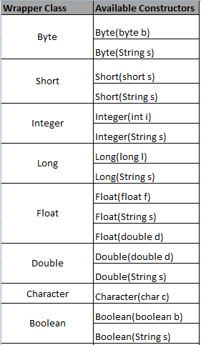

---------------------------------------------------------------------------------------------------------------------------

**What is AutoBoxing ?**

The process of automatic conversion of primitive data type in to its corresponding non primitive data type by the compiler is called autoboxing.

Eg :

Integer i = 25;

Boolean status = true;

AutoBoxing was introduced in JDK 1.5

---------------------------------------------------------------------------------------------------------------------------

**Explicit conversion :**

2 ways :

1st approach :

Integer age = new Integer(25);

2nd approach :

Integer age = Integer.valueOf(25);

--------------------------------------------------------------------------------------------------------------------

**What is Unboxing ?**

The process of automatic conversion of non primitive data type in to its corresponding primitive type by the compiler is called unboxing.

int age = new Integer(25);

-------------------------------------------------------------------------------------------------------------------

**Explicit conversion :**

int age = new Integer(25).intValue();

-------------------------------------------------------------------------------------------------------------------

**Program example**

public class WrapperClassDemo {

public static void main(String[] args) {

//Explicit conversion of primitive type to Non primitive type

byte b = 10;

Byte valueOf = Byte.valueOf(b);

//Implicit Conversion by the compiler (AutoBoxing)

Byte b1 = 10;

//Explicit conversion of Non primitive type to primitive type

Character c1 = new Character('c');

char charValue = c1.charValue();

//Implicit Conversion by the compiler (UnBoxing)

char ch = new Character('c');

//Conversion of int primitive type in to String format

int a = 10;

//explicit conversion of primitive type to non primitive type

Integer objFormA = Integer.valueOf(a);

//Use toString() method to convert in to String format

String aInStringForm = objFormA.toString();

System.out.println(aInStringForm);//10

//Use instanceof keyword to check whether it has converted in to String form

System.out.println(aInStringForm instanceof String);//true

//Conversion of boolean primitive type in to String format

boolean areYouMarried = true;

Boolean maritalStatus = Boolean.valueOf(areYouMarried);

String strFormat = maritalStatus.toString();

System.out.println(strFormat);//true

System.out.println(strFormat instanceof String);//true

//Convert String format in to int primitive type

Integer i = new Integer("20");

int ageInIntForm = i.intValue();

System.out.println(ageInIntForm);// 20 - primitive

//parseXXX() method

String age2 = "50";

int parseInt = Integer.parseInt(age2);

//Convert String format in to boolean primitive type

String maritalStatus1 = "true";

System.out.println("String format : "+maritalStatus1);

Boolean b3 = new Boolean(maritalStatus1);

boolean booleanValue = b3.booleanValue();

System.out.println("boolean type : "+booleanValue);

}

}

--------------------------------------------------------------------------------------------------------------------

**String**

→ is a sequence of characters

→ is a predefined class in java present in java.lang package.

→ is a direct subclass of Object class.

→ String is immutable in nature. That is, once a string object is created,it will not allow any modification. Still, if you want to make any changes, it will create a new String object.

***How many ways you can create String object ?:***

String object can be created by 2 ways.

1.By using string literal

2. By using new Keyword and String class constructor

---------------------------------------------------------------------------------------------------------------------------

How many constructors do you have in String class ?

There are 16 constructors in String class.

Few Important constructors are mentioned below.

1. String()
2. String(String s)
3. String(byte[] b)
4. String(char[] c)
5. String(StringBuffer sb)
6. String(StringBuilder sb)

---------------------------------------------------------------------------------------------------------------------------

String Object creation -- **By using string literal**

Eg :

String s1 = “java”;

→ String object created by literal will be stored in String Constant pool memory [SCP area].

Question : How string objects are created in SCP area ?

OR

Why duplicate objects are not allowed in SCP area ?

→ When an String object is created in SCP area, before it actually creates an object, it first

checks whether an object is already created with the same content in the SCP area. If it is not already created, then it creates an object, and if it is already created, it doesn’t create a new string object and its starts referring to the existing object. Hence, duplicate object is not allowed in SCP area.

Question : What do you mean by derefered objects ?

→ Objects which no longer have any reference are known as deferred objects.

Question : What happens to derefered object in SCP area ?

→ In SCP area, derefered objects are not eligible for garbage collection because garbage collector don’t have an access to SCP area. These derefered objects get released once the jvm is shut down. JVM will be shut down once we restart the server.

String Object creation -- By using new Keyword and String class constructor

Eg :

String s = new String(“java”);

1. String object created using new keyword and constructor will be created in HEAP area.
2. Duplicate objects allowed in HEAP memory. That is, if we try to create another string object with the same content, it will create a new object altogether. Hence, String are immutable in nature.
3. Any deferred objects in HEAP memory will be garbage collected.

--------------------------------------------------------------------------------------------------------------------

**String Concatenation :**

String can be concatenated using 2 options.

→ “ + ” operator

→ concat() method

**Using + operator :**

Eg: String message = “java” + “selenium”;

3 objects will be created in total. [2 in SCP and 1 object in HEAP]

1st object content : **java [SCP area]**

2nd object content : **selenium [SCP area]**

1st object content : **javaselenium [HEAP]**

**----------------------------------------------------------------------------------------------------------**

**Using concat() method**

**Eg :**

**String s = “java”;**

**s.concat(“selenium”);**

3 objects will be created in total. [2 in SCP and 1 object in HEAP]

1st object content : **java [SCP area]**

2nd object content : **selenium [SCP area]**

1st object content : **javaselenium [HEAP]**

**----------------------------------------------------------------------------------------------------------------**

**String comparison :**

Eg:

String s1 = “java”;

String s2 = “selenium”;

String s3 = “java”;

SOP(s1==s2); // false

SOP(s1==s3); // true

SOP(s1.equals(s2)); // false

SOP(s1.equals(s3)); // false

**----------------------------------------------------------------------------------------------------------------**